IDEATION PHASE
DEFINE THE PROBLEM STATEMENTS

Date | 08-12-2025
Team Id
Project name | Docspot
Maximum marks | 2 marks

Customer Problem Statement Template:

To define the core problems patients and doctors face while booking and managing medical appointments, and use those insights to guide the development of DocSpot
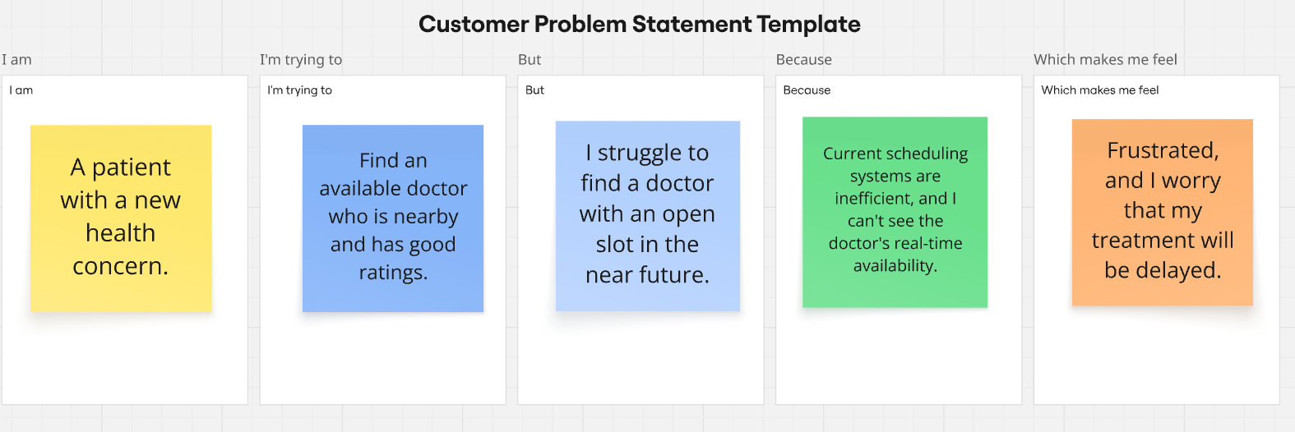.

Problem Statements (PS) | I am | I`m trying to | But | Because | Which makes me feel
Ps-1 | a busy working professional. | book a doctor’s appointment quickly without visiting the clinic physically. | most clinics still follow manual appointment booking or phone-based systems. | doctors' schedules are not easily visible online and appointment slots are not updated in real time. | inconvenienced and stressed, especially when I urgently need medical attention.
Ps-2 | a general physician running a small clinic. | manage daily appointments efficiently and reduce patient waiting times. | my appointment records are scattered across WhatsApp messages, phone calls, and handwritten notes. | I don’t have a centralized digital system to track bookings, cancellations, and patient history. | overwhelmed and unable to provide a smooth experience for my patients.
Ps-3 | a college student living away from home. | find a doctor nearby who is available at a convenient time. | I cannot easily compare doctor fees, specialties, and appointment slots in one place. | most clinics don’t provide transparent online information, and I have to visit or call multiple places. | confused, uncertain, and anxious about choosing the right doctor and managing my time.

